Climate Therapy Workshop

For therapists and therapy students: Shift Climate Change Overwhelm in yourself to better support others

Experiential Workshop includes Satir-inspired sculpting
With Lisa Martens, MMFT

Outdoor, Small Group

Register by August 10th

Cost $40, and $25 for students and low income

Friday August 12th, 2022
9:30 – 11:30 am
Assiniboine Park Winnipeg

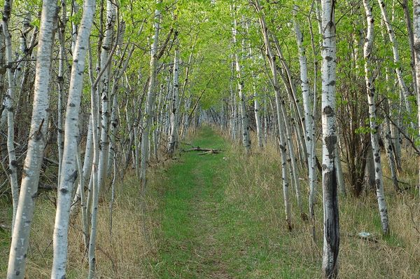

Registration Form below.
For more info, email lisadtherapy@protonmail.com

Photo: Assiniboine Forest Path,
By Dano; CC BY 2.0 license
Climate Therapy Workshop Registration Form
Friday August 12th, 2022, 9:30 – 11:30 am
Assiniboine Park (with indoor or zoom to be considered in case of severe weather)

Register by August 10th

Preferred Name: _________________________ Pronouns: __________

Phone number: _________________ Email: ______________________

Location at Park: We’ll meet near the South side of the footbridge (near the letter S on this map) and walk to a nearby spot
https://www.assiniboinepark.ca/uploads/public/images/maps/park-map.pdf

Snacks Provided: Fruit, vegetables, cheese, crackers (No beverages provided)

Bring your own:
- Lawn chair
- Beverage/s (Assiniboine park does not allow open alcohol) and additional snacks if wanted
- Bug spray, sunscreen, umbrella, etc. as wanted

Please submit registration form to lisadtherapy@protonmail.com and send fee by August 10th, 2022

E-transfer, cheque or cash accepted for fee: $40, or $25 for student and low income.

10% of fees, before expenses, will be paid to a group or organization run by - or collaboratively with - Indigenous people, in acknowledgement of Indigenous Peoples’ primary relationship with the lands and waters. This will not be sent as a donation but as a payment.

